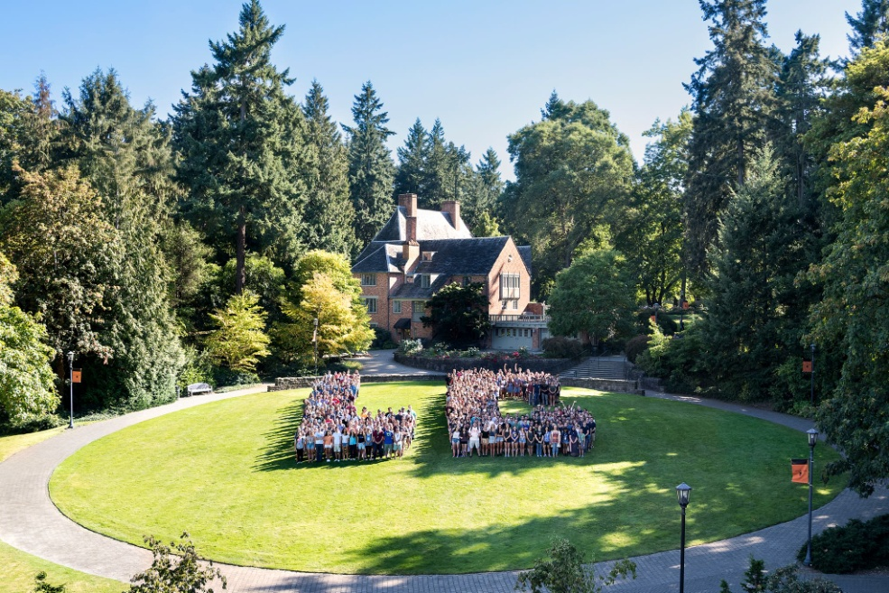
On behalf of the Lewis & Clark forensics team, I would like to welcome you to Portland and the Lewis & Clark campus for the National Parliamentary Tournament of Excellence. We are proud to host these events and we sincerely hope that you will enjoy your time on our campus.
These pages are designed to give you information on the campus and its environs. Please note that this information is provided from the host; if you have questions about tournament administration, please contact a member of the tournament staff.
Much of this information is repeated from the NPDA information packet, but some information is changed due to timing and the comparatively smaller size of tournament. Please read all of it to ensure you have the best information available.
We look forward to seeing you all and celebrating an amazing year of parliamentary debate.
Sincerely,
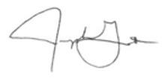
Joe Gantt
Director of Forensics
Lewis & Clark College

TOURNAMENT DATES
March 28 Registration
March 29 Preliminary Debates
March 30 Preliminary Debates/First Elimination Debates
March 31 Remaining Elimination Debates

DIRECTIONS
The tournament hotel is the Crowne Plaza in Lake Oswego.
Google maps link from the tournament hotel to Lewis & Clark:
https://bit.ly/2pLp8yr
Please check the map (or another map service) prior to leaving for campus. Depending on traffic, the hotel is about 15-20 minutes away from campus. There are two possible routes, but each could be longer or shorter depending on traffic situations at the time.
Traffic will be more problematic on Thursday and Friday than Saturday.
WHEN YOU ARRIVE
When you arrive on campus, look for gate 2 and turn left (the football field will be to your right after you turn). Follow that road down to the parking lots.

TOURNAMENT LOCATIONS
All competition and prep spaces are in JR Howard Hall. You can find JR Howard on the following map:
https://www.lclark.edu/live/files/7676-campus-map
Tournament headquarters will be in JR Howard 302, and topic announcement will occur in the JR Howard lobby.
INTERNET
You can access guest internet by following the instructions linked below:
http://www.lclark.edu/live/files/25408-safeconnect-guest-accesspdf
Please arrive early to ensure you have time to complete these steps. It is usually fairly easy to get a guest account set up, but there are occasionally complications.
SMOKING
Lewis & Clark is a Designated Smoking Area (DSA) campus. The nearest DSA to JR Howard is just to the west of the building (between JRH and the swimming pavilion). Please abide by this policy.
MARIJUANA
In Oregon, marijuana is legal to purchase and use for those over twenty-one years of age. However, as a federally-funded institution, Lewis & Clark follows federal law when it comes to the sale, possession, and use of marijuana or marijuana-infused products. The production, sale, possession, and use of marijuana or marijuana-infused products are prohibited on campus, and you may be asked to leave campus if you do not abide by this policy.
SEXUAL MISCONDUCT POLICY
Members of the college community, guests, and visitors have the right to be free from sexual misconduct. You can find the full Lewis & Clark policy at:
https://www.lclark.edu/live/profiles/3680-sexual-misconduct-resources-and-support-policy
DISCRIMINATION, HARASSMENT, AND HATE OR BIAS-MOTIVATED CONDUCT POLICY
Lewis & Clark College prohibits harassment of all kinds, and discrimination, and hate or bias motivated conduct that is based on any of the characteristics set forth below.
- Color, race, ethnicity, national origin, ancestry or citizenship status;
- Age, physical or mental disability, medical condition, socioeconomic status or veteran status;
- Sex, sexual orientation, gender identity or gender ;
- Religious belief or practice, marital status or domestic partner status;
- Any other characteristic protected by applicable local, state or federal law.
You can find the full Lewis & Clark policy at:
https://www.lclark.edu/live/profiles/3660-hate-and-bias-motivated-conduct-policy
GENDER NEUTRAL BATHROOMS
Gender neutral bathrooms are available on the 1st floor of JR Howard in both wings of the building.
CAMPUS SAFETY
Should you need to reach our Campus Safety, their number is 503-768-7777.

ALL OTHER HOST-RELATED INQUIRIES
You can reach me on my cell at 806-777-9904.
MISCELLANEOUS CAMPUS NOTES
- As of the time of this writing, weather looks partly cloudy with highs in the high 50s and lows in the low 40s. It looks pleasant, but beware that forecasts in Portland change frequently.
- When you get a bit of free time, we highly recommend you go to the Estate Gardens (just east of the Frank Manor House). It is a great place for a team picture as it is one of the most beautiful areas of campus (especially if we are lucky enough to have a clear day).

SUPPLIES NEAR CAMPUS
Grocery Stores

Market of Choice 8502 SW Terwilliger Blvd, Portland, OR 97219 (503) 892-7331
Fred Meyer 7555 SW Barbur Blvd, Portland, OR 97219 (503) 452-3000
Safeway 8145 SW Barbur Blvd, Portland, OR 97219 (503) 452-6068

New Seasons 1214 SE Tacoma St, Portland, OR 97202 (503) 230-4949

Safeway 1100 NE Broadway St, Portland, OR 97232 (503) 528-0500
New Seasons 3210 NE Broadway St, Portland, OR 97232 (503) 282-2080
Office Supplies
Office Depot 15060 SW Sequoia Pkwy, Tigard, OR 97224 (503) 639-3880
Office Depot Gateway Center, 9908 NE Halsey St, Portland, OR 97220 (503) 251-5851

DINING
If you have not been to Lewis & Clark before, you will realize that the campus is a beautiful area somewhat secluded from the rest of Portland. That seclusion also means that we are not the typical college campus when it comes to food; there are not food choices available within walking distance. Additionally, it is spring break- so our bookstore and other options for snacks are not available. There are some vending machines (Evans, Watzek Library, Templeton) but the options are limited.
I highly urge you to bring snacks with you to the tournament.
Lunch will be served in the Stamm meeting room in the Templeton Student Center on all three days. (Stamm is on the same floor as Fields but is a different room). Each participant will receive a ticket to enter Stamm during the lunch break. That ticket is good for all three days.
There will be coffee service with bagels, muffins and fruit available in the JR Howard lobby on each morning of the tournament.

FAST FOOD OPTIONS NEAR CAMPUS
Subway Sandwiches 8730 SW Terwilliger Blvd #101, Portland, OR 97219 (503) 246-1799
Baja Fresh Mexican/Fast Casual 7421 SW Barbur Blvd ste 190, Portland, OR 97219 (503) 595-0399
Taco Bell Mexican/Fast Food 7710 SW Barbur Blvd, Portland, OR 97219 (503) 977-6271
KFC Fried Chicken 7641 SW Barbur Blvd, Portland, OR 97219 (503) 246-4233
Wendy’s Burgers/Fast Food 9445 SW Barbur Blvd, Portland, OR 97219 (503) 244-8362
Taco Time Mexican/Fast Food 9455 SW Barbur Blvd, Portland, OR 97219 (503) 246-1869
Pizza Hut Pizza 7405 SW Barbur Blvd, Portland, OR 97219 (503) 452-2815
Muchas Gracias Mexican/Fast Casual 8981 SW Barbur Blvd, Portland, OR 97219 (503) 245-5597
BETTER, BUT MORE TIME CONSUMING, OPTIONS NEAR CAMPUS
Noy Viet Lao Vietnamese 3530 SW Multnomah Blvd, Portland, OR 97219 (503) 686-9367
Otto & Anita’s European Restaurant German 3025 SW Canby St, Portland, OR 97219 (503) 452-1411
Baja Fresh Fast Casual 7421 SW Barbur Blvd #190, Portland, OR 97219 (503) 595-0399
Verde Cocina Mexican 6446 SW Capitol Hwy, Portland, OR 97239 (503) 384-2327
Bamboo Grove Hawaiian Grille Hawaiian 515 SW Carolina St, Portland, OR 97239 (503) 977-2771
Casa Colima Mexican 6319 SW Capitol Hwy, Portland, OR 97239 (503)892-9944
Sasquatch Brewing Company Brewpub 6440 SW Capitol Hwy, Portland, OR 97239 (503) 402-1999
Salvador Molly’s Caribbean 1523 SW Sunset Blvd, Portland, OR 97239 (503) 293-1790
Marco’s Café Espresso Bar 7910 SW 35th Ave, Portland, OR 97219 (503) 245-0199
Buffalo Gap American 6835 SW Macadam Ave, Portland, OR 97219 (503) 244-7111
Frack Burger Burgers 8981 SW Barbur Blvd, Portland, OR 97219 (503) 245-5597
Opa Pizzeria Pizza 8000 SE 13th Ave, Portland, OR 97202 (503) 238-7255
Killer Burger Burgers 8728 SE 17th Ave, Portland, OR 97202 (503) 841-5906
A Cena Ristorante Italian 7742 SE 13th Ave, Portland, OR 97202 (503) 206-3291
Thai Square Thai 8601 SE 17th Ave, Portland, OR 97202 (503) 206-5008
Grand Central Baking Company Soup & Sandwich 7987 SE 13th Ave, Portland, OR 97202 (503) 546-3036
Saburo’s Sushi House Japanese 1667 SE Bybee Blvd, Portland, OR 97202 (503) 236-4237

CLOSER TO DOWNTOWN PORTLAND
Hopworks Brewpub 2944 SE Powell Blvd, Portland, OR 97202 (503) 232-4677
Screen Door Southern 2337 E Burnside St, Portland, OR 97214 (503) 542-0880
Kala Noodle & Grill Thai 2534 SE Belmont St, Portland, OR 97214 (971) 302-6115
Nong’s Khao Man Gai Thai 609 SE Ankeny St, Portland, OR 97214 (503) 740-290
Toro Bravo Tapas 120 NE Russell St, Portland, OR 97212 (503) 281-4464
Lardo Pork Sandwiches 1212 SE Hawthorne Blvd, Portland, OR 97214 (503) 234-7786
Fire on the Mountain Wings 1708 E Burnside St, Portland, OR 97214 (503) 230-9464
Russell Street BBQ Barbecue 325 NE Russell St, Portland, OR 97212 (503) 528-8224
Pok Pok Thai 3226 SE Division Street, Portland, OR 97202 (503) 232-1387
Sen Yai Thai 3384 SE Division St, Portland, OR 97202 (503) 236-3573
Koji Osakaya Japanese 1502 NE Weidler St. Portland, OR 97232 (503) 280-0992
Burgerville Burgers/Fast Food 1122 SE Hawthorne Blvd, Portland, OR 97214 (503) 230-0479
¿Por Qué No? Mexican 4635 SE Hawthorne Blvd, Portland, OR 97215 (503) 954-3138
Portland City Grill American/Asian Fusion 111 5th Ave, 30th Floor, Portland, OR 97204 (503) 450-0030
Porto Terra Italian 830 SW 6th Ave, Portland, OR 97204 (503) 944-1090
Le Bistro Montage Cajun/Creole 301 SE Morrison St Portland, OR 97214 (503) 234-1324

Mi Mero Mole Mexican 32 NW 5th Ave, Portland, OR 97209 (971) 266-8575

Pambiche Cuban 2811 NE Glisan St, Portland, OR 97232 (503) 233-0511
Voodoo Donuts Donuts 1501 NE Davis St, Portland, OR 97232 (503) 235-2666

Yelp link- Sellwood (just east of the Willamette River. On way back to NPDA hotel, but beware that the Sellwood bridge can cause delays)
https://www.yelp.com/search?cflt=restaurants&find_loc=Sellwood%2C+Portland%2C+OR
Yelp link- Hillsdale (northwest of campus)
https://www.yelp.com/search?find_desc=Restaurants&find_loc=Hillsdale%2C+Portland%2C+OR&ns=1
Yelp link- Lake Oswego (near NPTE hotel)
https://www.yelp.com/search?find_desc=Restaurants&find_loc=Lake+Oswego,+OR

